CHAPTER 1

INTRODUCTION

Artificial Intelligence (AI) and Machine Learning (ML) have become integral components of modern digital systems. With the exponential growth of data generated by online platforms, organizations are increasingly dependent on intelligent systems to analyze user behavior and make strategic decisions.
In today’s competitive digital environment, customer retention has become more important than customer acquisition. Understanding why users disengage from products and predicting such behavior in advance is crucial.
This project focuses on predicting user churn using AI techniques and deploying the solution using Docker and Kubernetes.

CHAPTER 2

LITERATURE REVIEW

Customer churn prediction has been widely studied in data mining and machine learning research.
Traditional statistical methods were limited in handling complex patterns.
Modern machine learning techniques have improved accuracy but often ignore deployment challenges.

CHAPTER 3

PROBLEM STATEMENT

Customer churn negatively impacts revenue and growth.
Manual and delayed analysis methods are ineffective.
An automated, scalable AI system is required.

CHAPTER 4:

OBJECTIVES

Design an AI-based churn prediction system.
Provide a user-friendly dashboard.
Deploy the system using Docker and Kubernetes.

CHAPTER 5

SYSTEM ARCHITECTURE

The system follows a microservices architecture.
Streamlit acts as the frontend, FastAPI as the backend.
Kubernetes manages deployment and scaling.

CHAPTER 6

CONCLUSION

This project demonstrates end-to-end AI system development.
It aligns academic learning with industry practices.
The project prepares the developer for real-world AI roles.
Screenshots

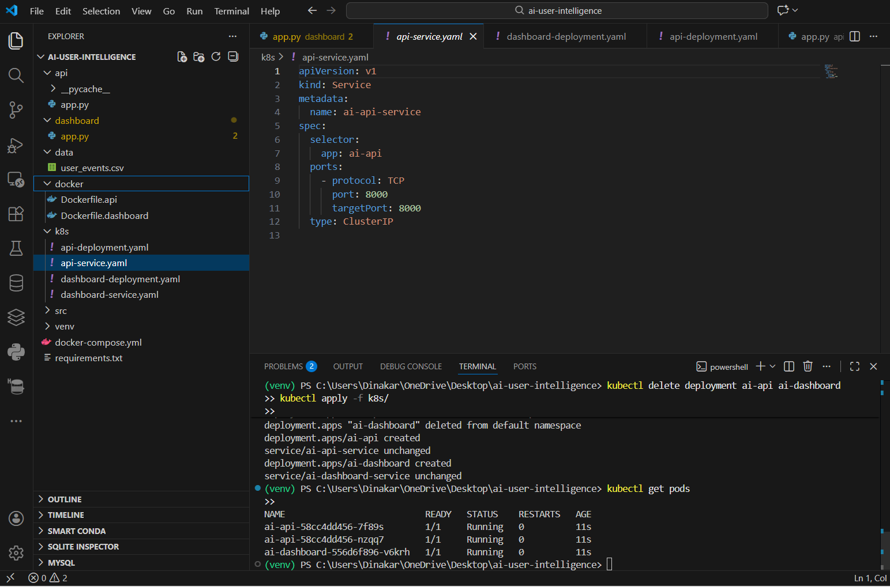
Visual Studio

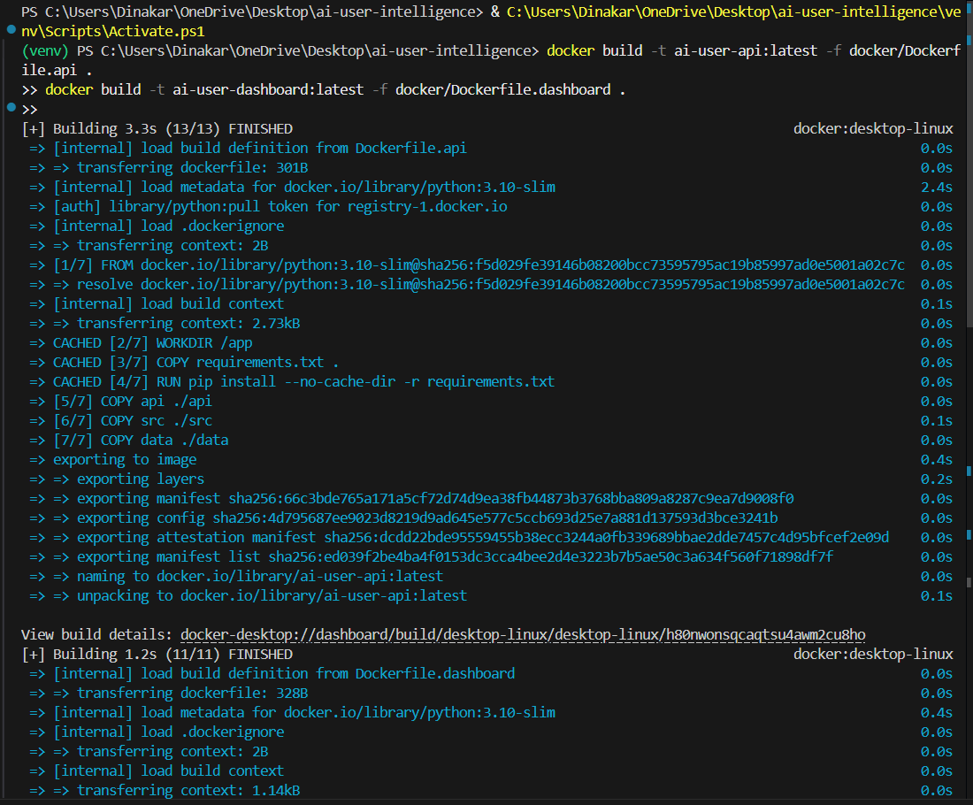
Docker Build

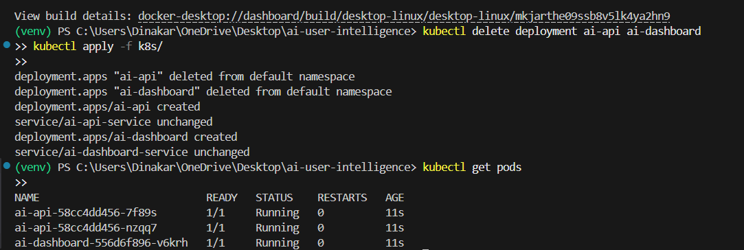
Kubernetes Deployment

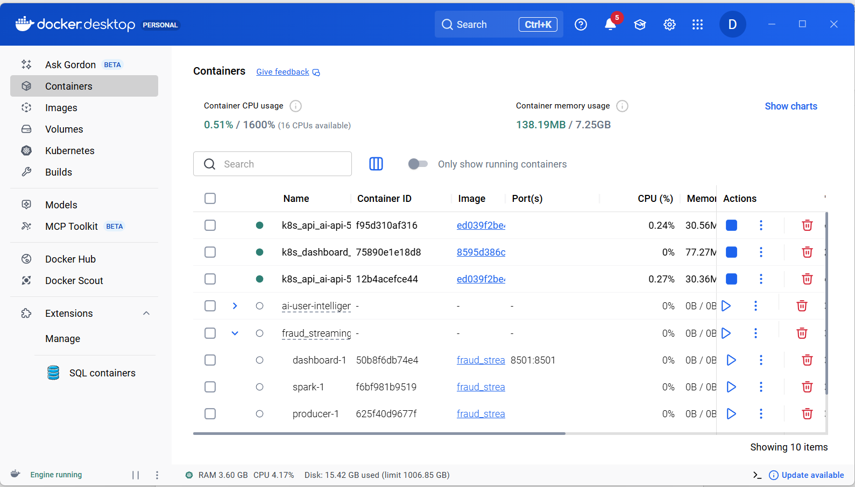
Docker Desktop

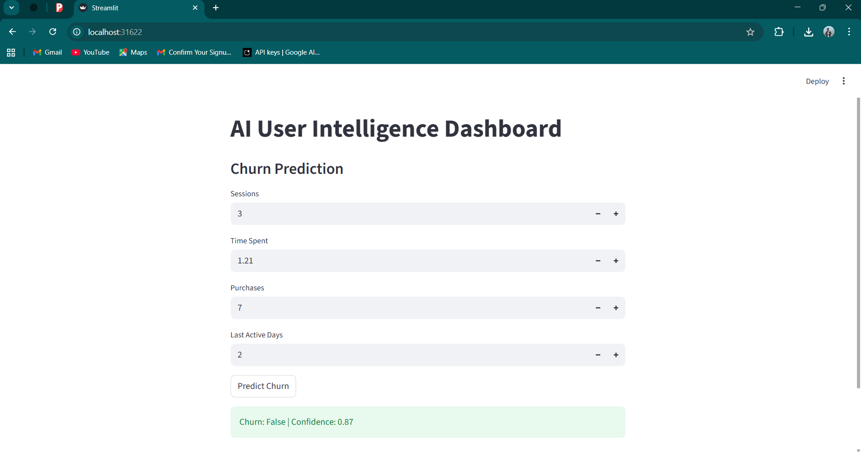
Streamlit Dashboard

